INTRODUCTION:

<title> is used to lock/unlock PC running on any operating system using Arduino Leonardo and RFID(Radio Frequency Identification) tags.

RFID Scanner/Reader is used to scan the RFID tag and it is connected with Arduino Leonardo by soldering. RFID is one of the oldest wireless technology. RFID chips are used to store information digitally, which can then be shared between objects through electromagnetic fields and radio waves. It may not be super-advanced, but many makers see real potential in the technology, no matter how old.

The heart of this project is Arduino Leonardo with ATmega32U4 chip.We can’t use development boards like Arduino UNO, Mega 2560, Pro Mini or Arduino Nano for this application. The reason is, the Arduino Leonardo has built-in USB Connection that allows the Leonardo to appear to a connected computer as a mouse or a keyboard.

keyboard.h core library is used to make the Arduino send the keystrokes to a connected computer. The code stores the UID of the RFID card and Windows password. When the right card is shown to the RFID reader, the Arduino will send keystrokes for locking the windows and password for unlocking the windows. When the system is already in lock state, the command will unlock the system or else the system is already in unlock state, the command will lock the system. There is only a pinch of delay between lock and unlock keystrokes.

The Arduino IDE running on the PC/Laptop will compile and insert the code into the Leonardo which starts executing the project.

PROBLEM STATEMENT:

The project is to design a system for locking/unlocking PC without entering the username and password using RFID tag and Arduino Leonardo. This is the easiest and cheap way of locking/unlocking a PC/laptop.

People often feel tired of typing in the password to unlock PC/laptop every time it get locked. Sometimes we may forget our Windows password or there is a possibility that it might be cracked. In the growing technology, time and security are to be concerned; Modern technologies require Modern innovations. People like Programmers, Game developers, Data analysts, etc, find it a time consuming job to logout and login a PC during work while taking a break. When the need for something becomes essential, we are forced to find ways of getting it. <title> would greatly help in reducing the time consumed in logging-in the PC. The user just need to scan their RFID tag to login their PC with <title>. This system can be used in schools, colleges, universities, offices where the user can lock/unlock their PC/Laptop just by scanning their ID Card.

With this system in place no more hassles of unlocking our Laptop/PC every-time we lock it down.

COMPONENTS REQUIRED:

* Arduino Leonardo
* RFID Card
* RFID Tag
* 10k ohm Transistors- 3 nos.
* Connecting wires
* Soldering Iron
* Breadboard
* Jumper wires
* LED
* RFID Sensor Module-RC 522
* Printed Circuit Board
* A Windows PC

SCHEMATIC DIAGRAM:

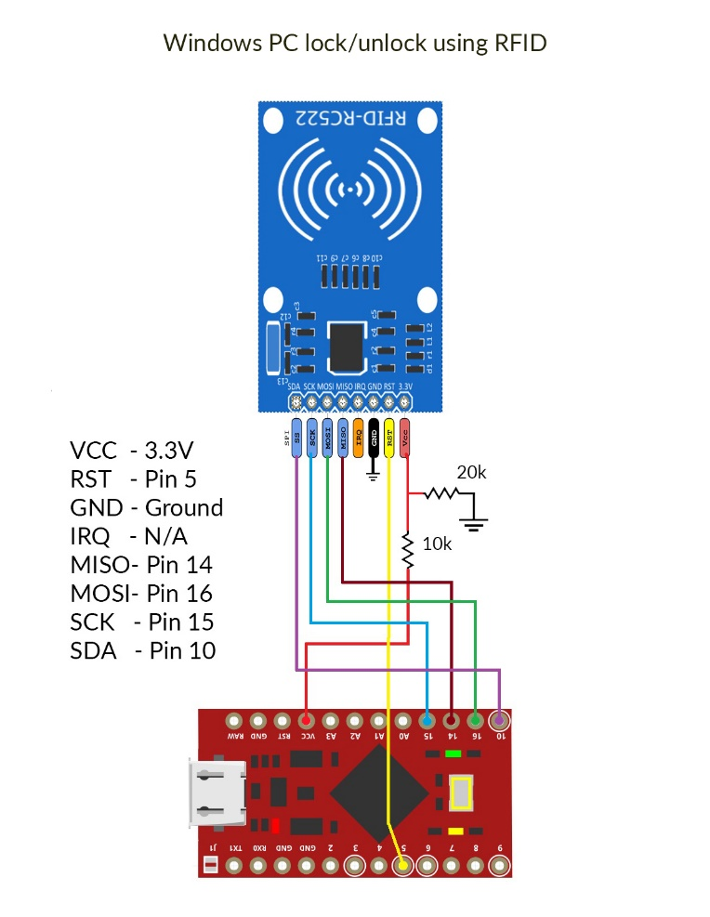

CODE:

CHALLENGES FACED:

Getting the Arduino Leonardo board.

The connections of jumpers and wires may not be